LONDON COLNEY PARISH COUNCIL

APPLICATION FOR A MEMORIAL TREE OR BENCH

Thank you for your interest in erecting a memorial in London Colney. Please complete the application form and return by email to info@londoncolney-pc.gov.uk or by post to:

London Colney Parish Council
Caledon Community Centre
Caledon Road
London Colney
Herts AL2 1PU

Name of Applicant

Address

Phone (home)

Phone (mobile)

Email address

What Memorial would you like to erect? (please tick preferred option) | BENCH  TREE
TREE OPTIONS

Please state which species of tree you would prefer. Please leave this section empty if you don’t have a preference. NB Only native British species will be planted.
Where would you like the tree?
Please give the site name and describe or sketch your preferred location. If you only give a site name, the Council will decide on a suitable location
Would you like to present at the planting?
The tree planting season runs from November – March.

MEMORIAL PLAQUE

Please print the wording CLEARLY IN BLOCK CAPITALS in the box. Carefully check the spelling as this will avoid your memorial being delayed.
Inscription Wording

Design of Memorial Bench

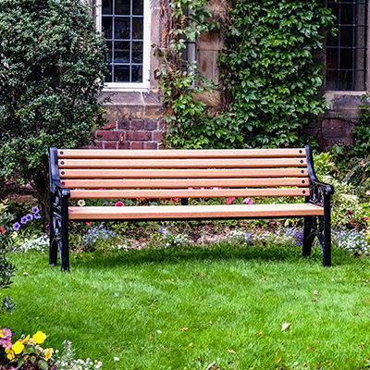

What next?

The Council will acknowledge receipt of your application and it will be discussed at the next Environment & Neighbourhood Committee meeting. The Council’s decision is final.

You will be invoiced for the full amount at the time of planting/installing bench.

PLEASE SIGN AND DATE BELOW TO CONFIRM YOU UNDERSTAND THE FOLLOWING:

- I have completed the form and the information I have provided is correct.
- I understand the Council will not be liable for any mistakes I have made in providing this information.
- I agree to abide by the Memorial Policy that accompanies this application.
- The Council will make every effort to maintain your tree but as it will be installed on a public site it cannot be held liable for any damage or vandalism.
- The Council will guarantee the tree against defect (drought, poor quality stock and poor-quality maintenance) until established, which usually takes 1-2 years.

Name

Date

If sending electronically please enter your name, we will deem this to be confirmation of you accepting the above.

